Portfolio of James Arthur Johnson
Direct public access (NOTE: All sites assume at least involvement of XHTML or HTML5 and CSS in their development; additional technologies used in the development are noted and specified):
- Related Links (BrightEdge replacement) – This feature uses my script https://www.jmu.edu/web_ssi/related-links/related-links-json.js which reads a relevant JSON file. So, at https://www.jmu.edu, it reads https://www.jmu.edu/_related-links/index.shtml.json since it gets the path as index.shtml. It then supplies the links from the JSON file. And different pages show different related links at the bottom of the page.
- New Campus Directory – https://directory.jmu.edu – Developed in partnership with Hannon Hill and the Identity Management Team
- Real-time Parking lot counts - https://www.jmu.edu/parking/ and sibling Parking sites pull in counts from a Perl script I wrote.
- Tooltips - Hover effect added over certain terms where this is enabled for a click look-up of the term or even rich content to search for more information. Look at the example below and the effect if one hovers over the “wiring” term. Example URL: https://www.jmu.edu/cascade/docs/articles/index.shtml.
- James Madison University Total Compensation Calculator “Benecalc” converted from a Visual Basic application to a client-side JavaScript app with a dynamic form and output using https://www.amcharts.com/. Developed in January 2018. Scheduled to go “live” in Spring 2018. Development URL: http://www.jmu.edu/humanresources/totalcomp/index-test.shtml. Production URL: https://www.jmu.edu/humanresources/totalcomp/index.shtml.
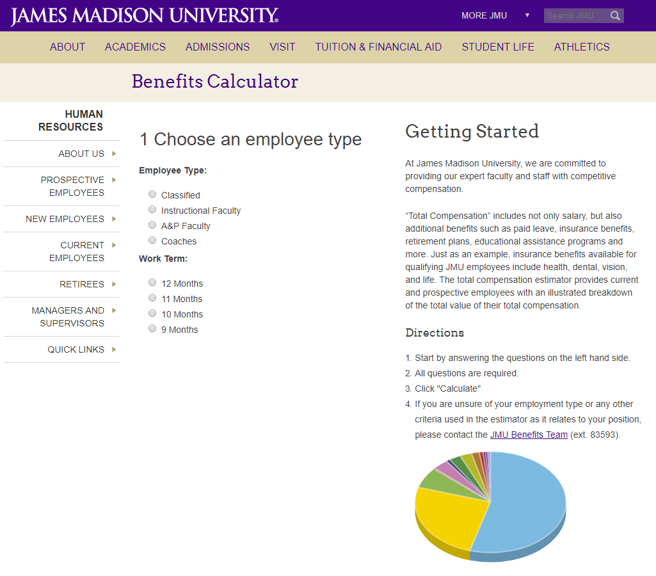
The form changes based on selection:
Classified:
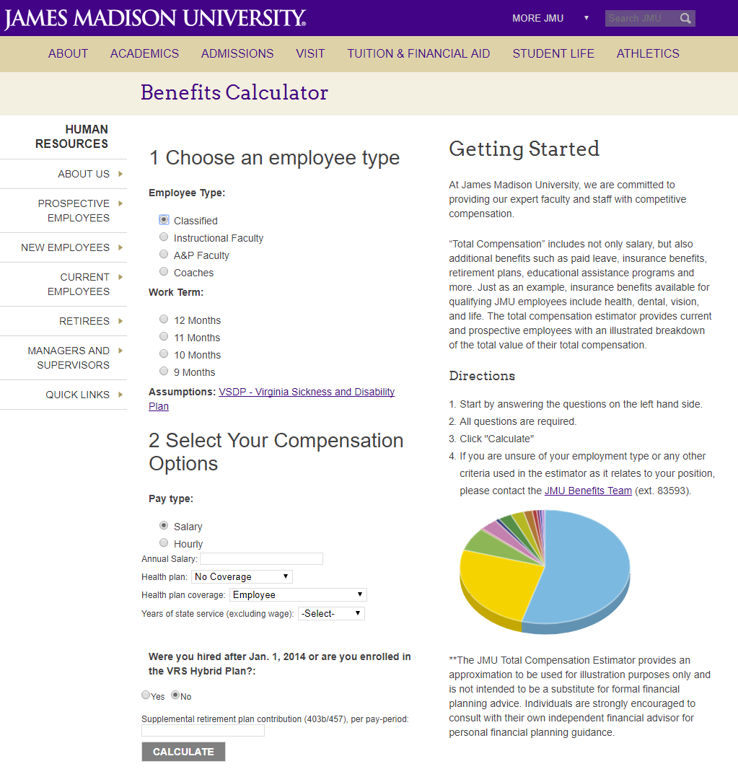
Or Instructional Faculty:
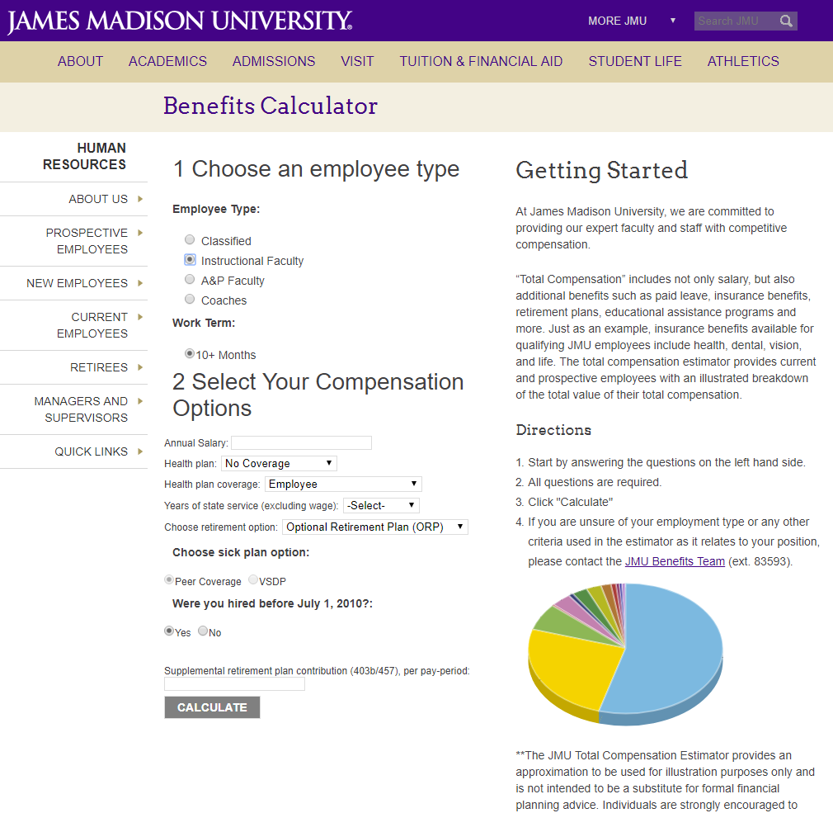
And there are other dynamic behaviors therein. The form also has validation, which will disable submission until the entry is corrected. Once entries are entered correctly and the form submitted, the output occurs in-page with a beautiful (and downloadable) 3-D pie chart from https://www.amcharts.com/, using the variables and calculations from the form. Further, calculations are based on multiple coefficients stored in the CMS. My VelocityScript pulls these coefficients into strings, which are split into variables used in the JavaScript.
Here is a sample output:
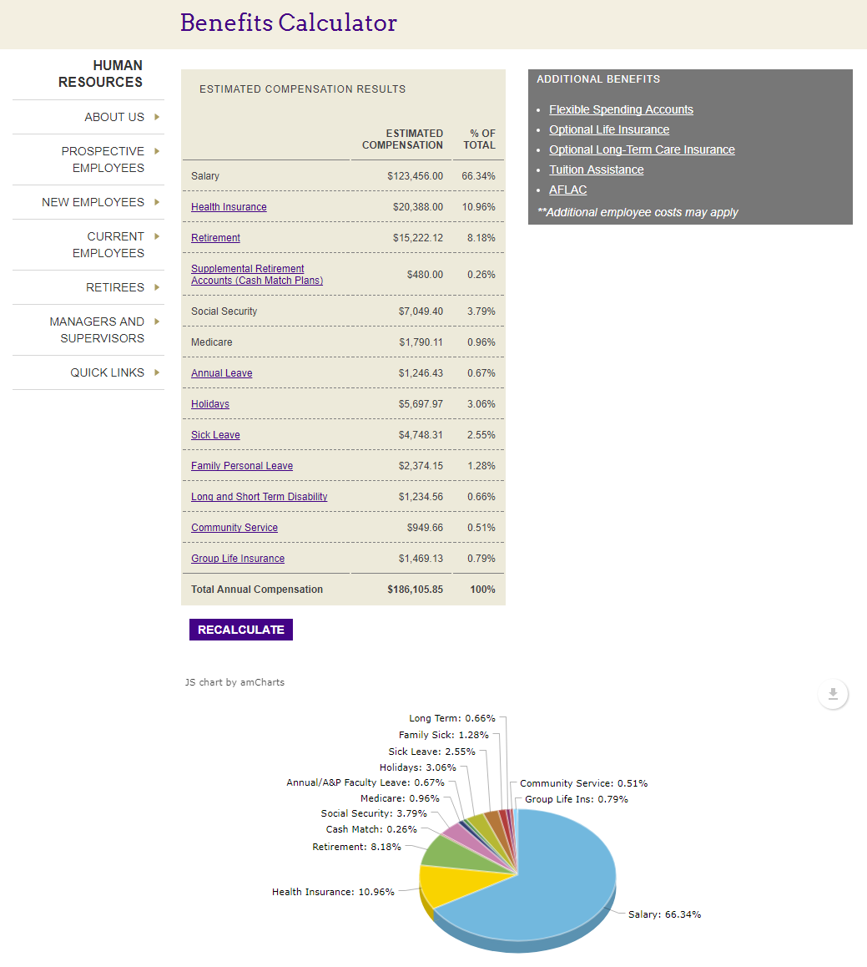
And of course it is mobile-friendly:
Input: Output:
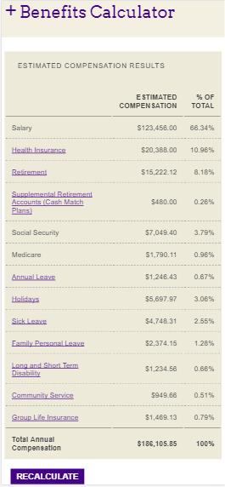
(Note: Chart hides at resolutions 640px and below)

- James Madison University Study Abroad Map. An interactive map that is also responsive. URL: http://www.jmu.edu/global/abroad/map/
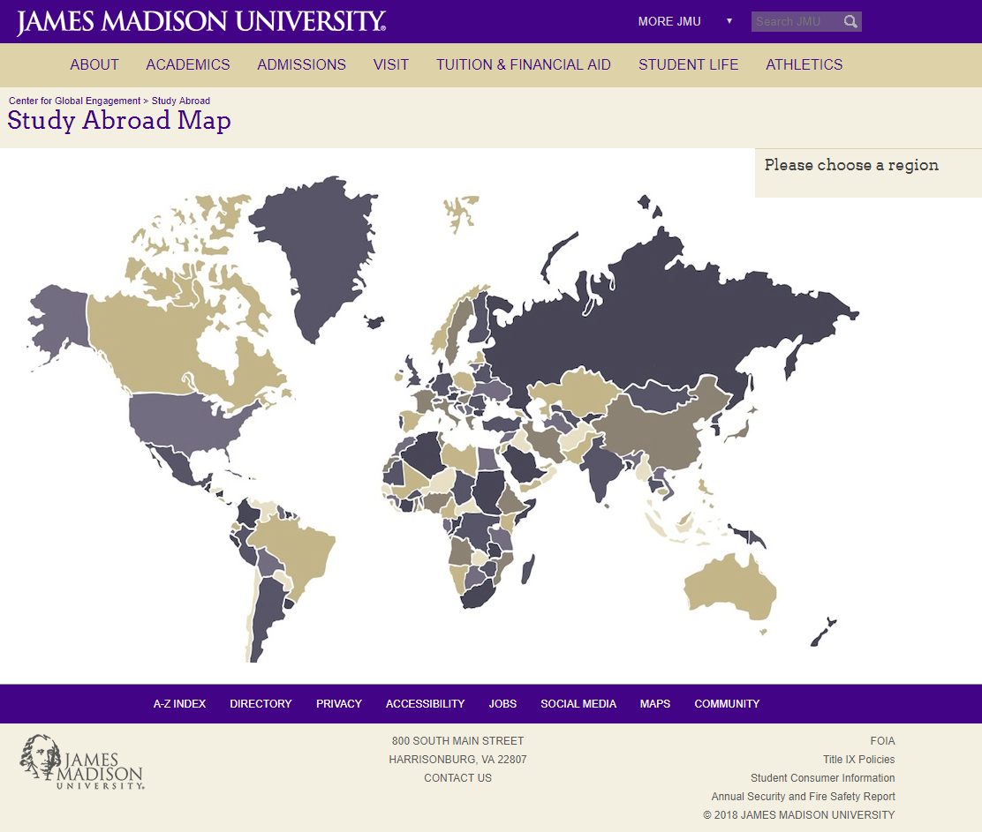
Mouse hover selects part of the map:
Or one can select using the drop-down select menu activated on desktop by hover:
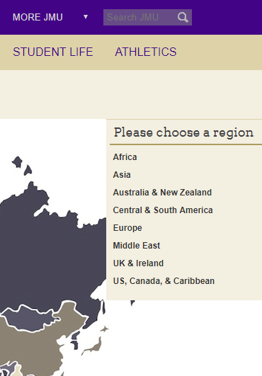
On mobile device in landscape orientation, one will still see the map and a drop-down select menu activated by touch:
One can also touch the map to be directed to the related Study Abroad Program.
Due to the impracticality of a map at smaller resolutions, it does not appear. However, the user can still get to the needed information using the drop-down select menu:

- James Madison University mobile-first responsive site. I was the developer for all Velocity Script, JavaScript, jQuery, CSS implementations, with technical architecture and support from Alvin Chao and design from Randy Budnikas and JMU University Marketing.
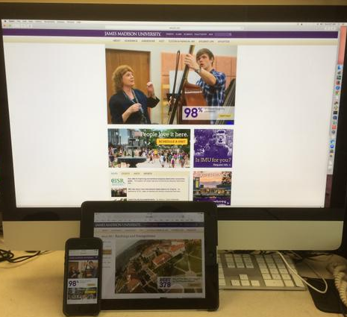

320 x 480:

Primary Page (without side navigation):

320 x 480:
Expandable header navigation:

320 x 480:
Secondary page with expandable side navigation:

768 X 1024:
Primary page (without side navigation):

768 X 1024:
Secondary page (with side navigation):

Desktop Resolution:
Primary page (without side navigation):
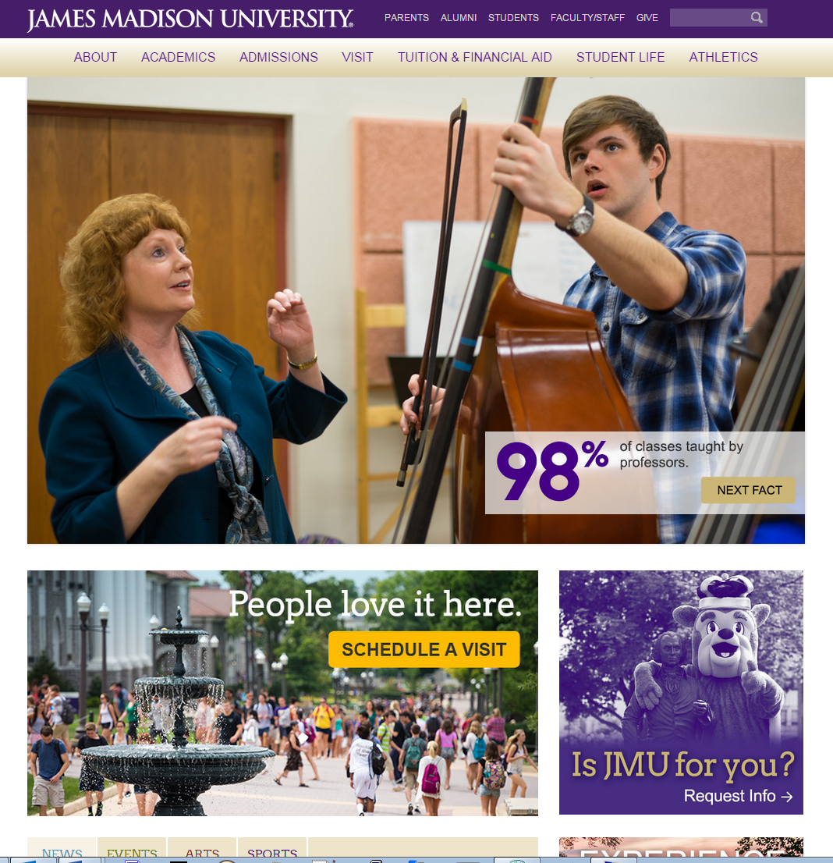

Desktop Resolution:
Primary page (without side navigation) lower page featuring tabbed news/events/arts/sports feeds, Instagram feed and Twitter feed:
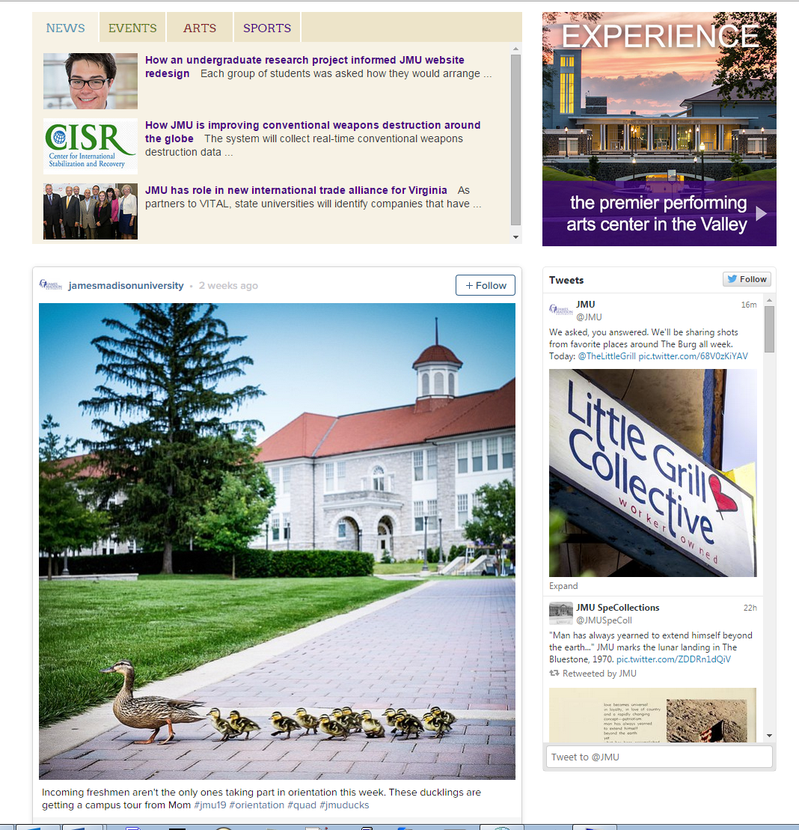

Desktop Resolution:
Primary page (without side navigation) footer, also responsive:

Desktop Resolution:
Primary Page (with no side navigation) using header navigation:
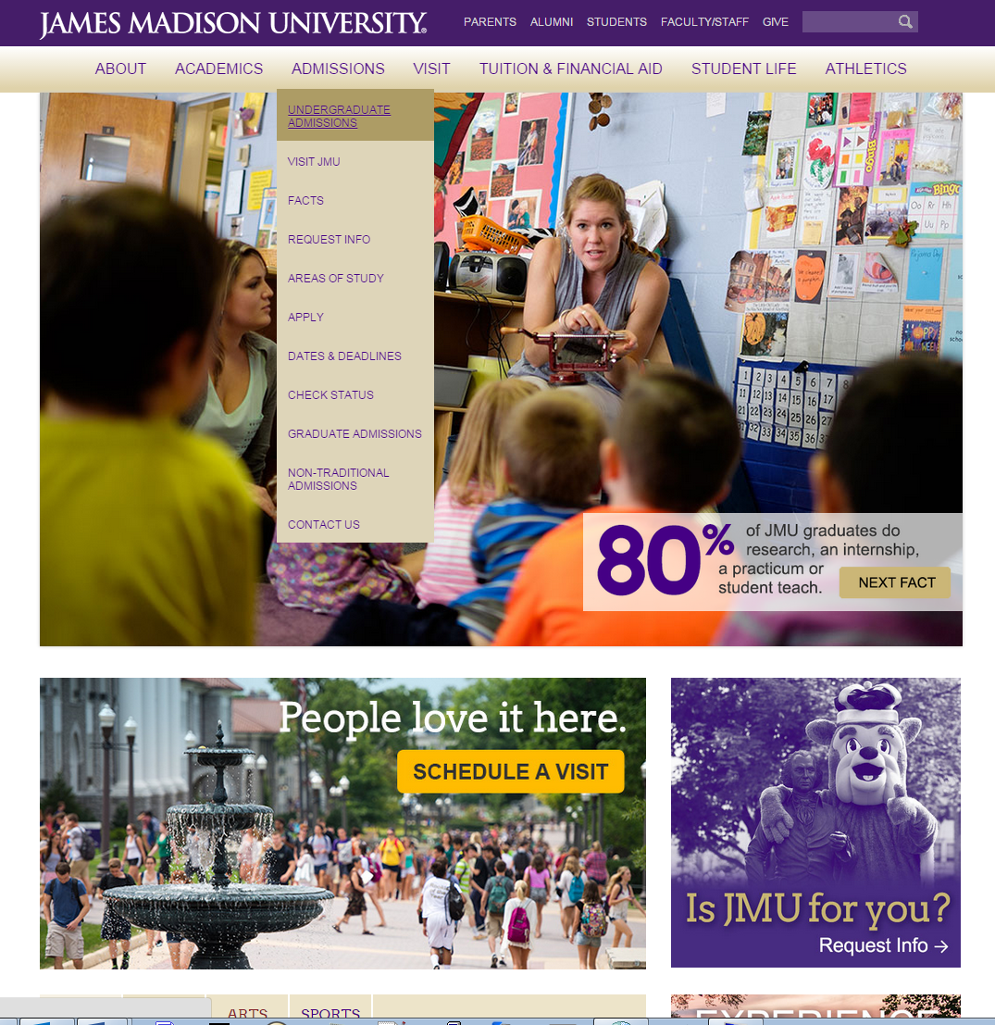

Desktop Resolution:
Secondary page (with side navigation):

Desktop Resolution:
Secondary page with side navigation, which toggles and highlights location:
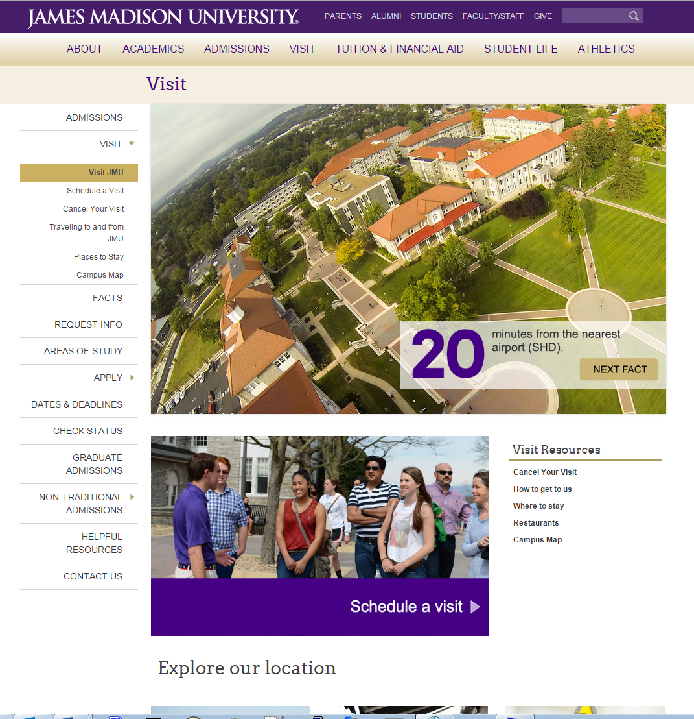

Secondary page (with side navigation) in-page footer and footer, which are both responsive:
I later updated the look without the gradient and changed/added other features. Here’s the home page: 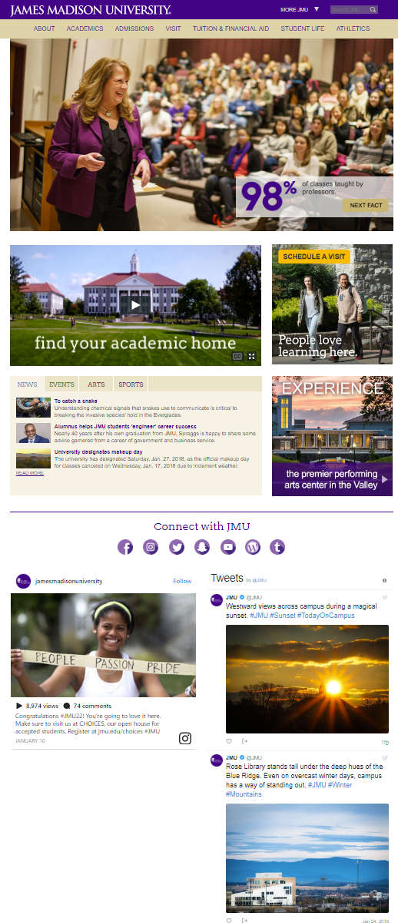
And here’s a secondary page, many now with breadcrumbs:
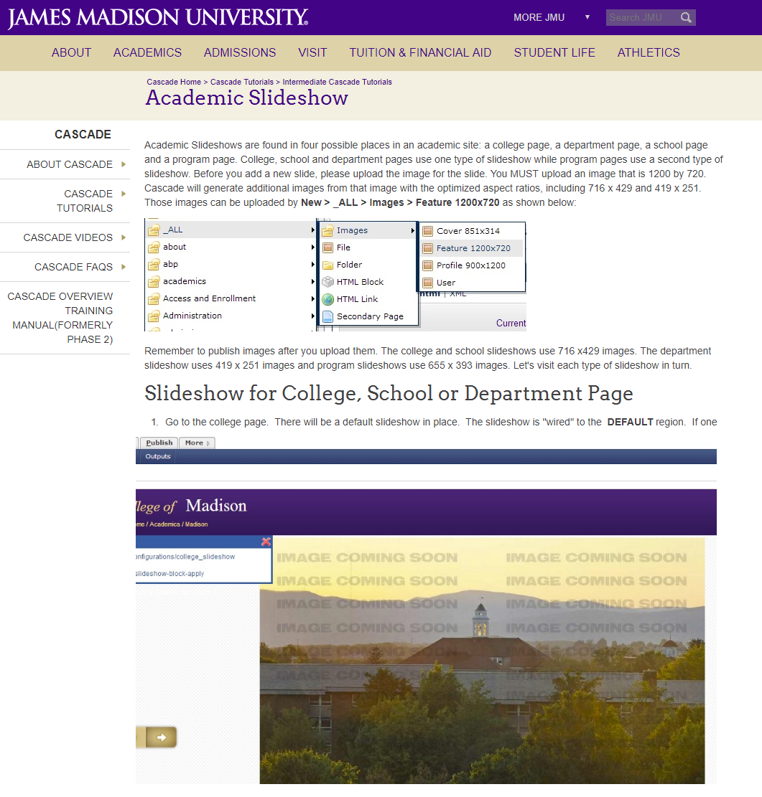
And of course, it continues to be responsive and mobile-friendly, looking very much like the above mobile screenshots.

- Center for the Interdisciplinary Study of Terrorism & Peace (CISTP) (design by Dr. Jennifer Connerley and James Arthur Johnson. Development by James Arthur Johnson with content by Dr. Jennifer Connerley and Dr. Frances Flannery), URL: http://www.jmu.edu/cistp/
Full Version:

Responsive (smaller images and expandable/collapsible menu at smaller resolutions:
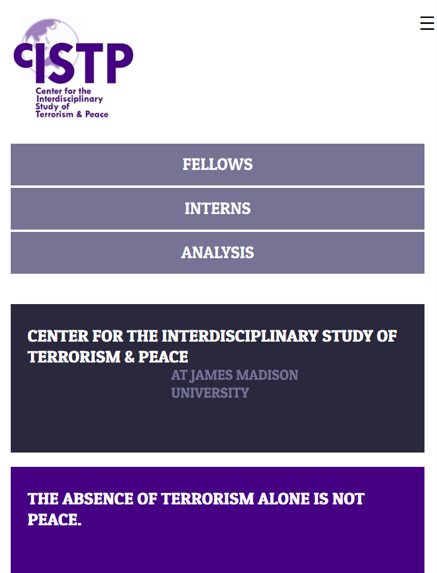

Less important content disappears at even smaller resolutions:
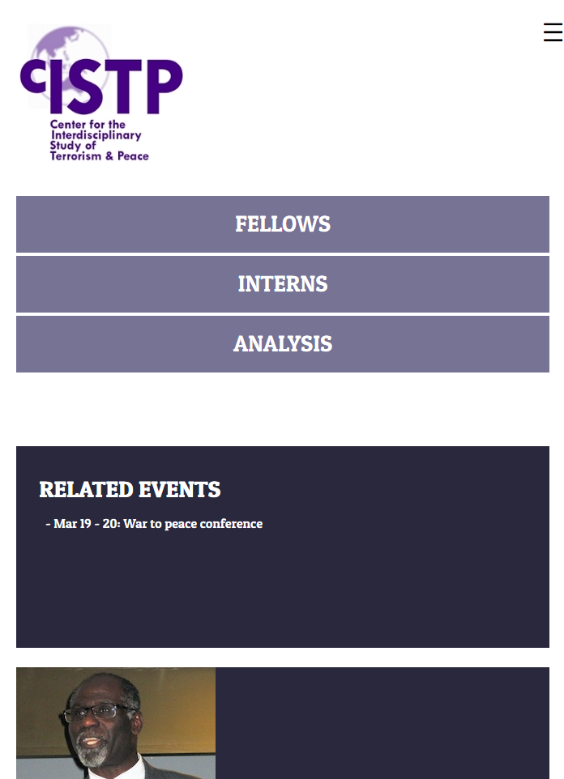

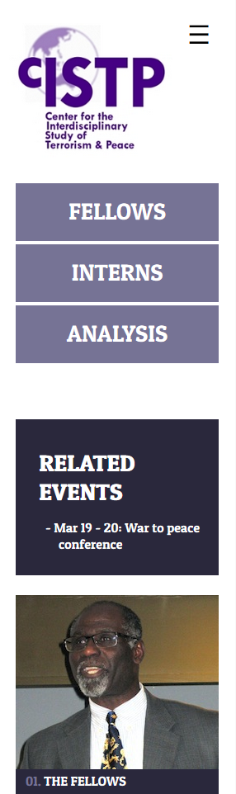
Left:
Responsive at lower resolution.
Middle:
Navigation at lower resolution expanded.
Right:
Mobile rendering.

- Author of Velocity: The Basics: Scripting with a $ here and a # to do
Kindle Edition: http://www.amazon.com/dp/B00IMM9J96?&tag=rnwff-20
Google Play: https://play.google.com/store/books/details/James_Arthur_Johnson_Velocity_The_Basics?id=iQvpAgAAQBAJ

- A Book For The ‘Burg (design by Amanda Bodle and James Arthur Johnson. Development by James Arthur Johnson), URL: http://abookfortheburg.com/
Full Version:
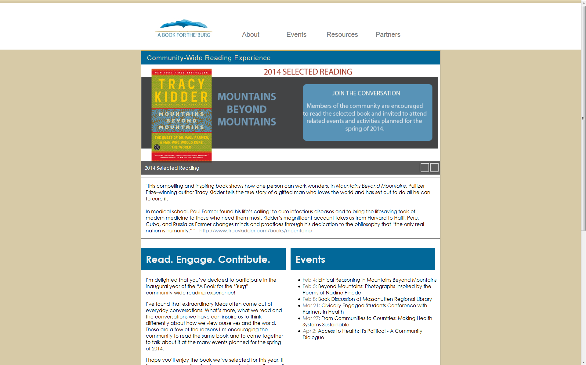
Responsive (smaller images and expandable/collapsible menu at smaller resolutions:
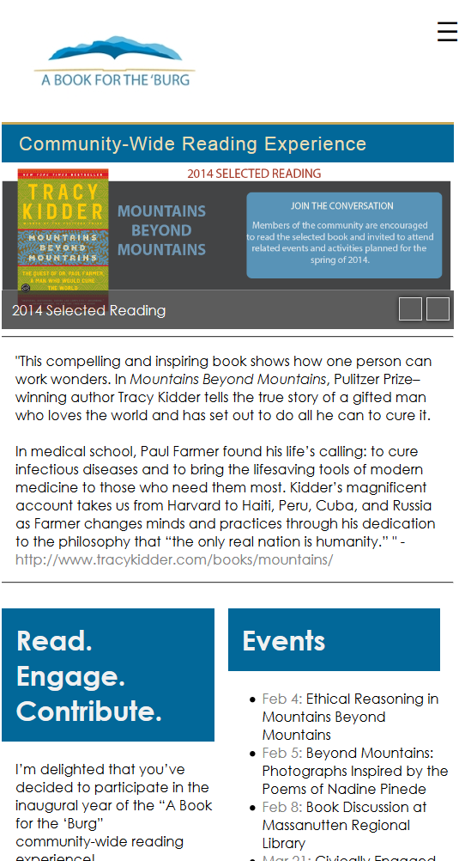
- JMU School of Art, Design and Art History (with much design and dynamic side navigation jQuery code by James Arthur Johnson), URL: http://www.jmu.edu/artandarthistory/
- Virginia Alliance for Secure Computing and Networking (VA SCAN) (with most coding and some graphics by James Arthur Johnson, all responsive coding and design by James Arthur Johnson, responsive on multiple devices and platforms), URL: http://vascan.org
Full version:
Responsive:
Responsive at an even smaller resolution (navigation collapses and is accessible via touch):
Full secondary page:

Responsive Secondary Page:

Secondary page with YUI grids laid out like a table:

Secondary page with YUI grids laid out like a table - responsive:

Windows Phone:

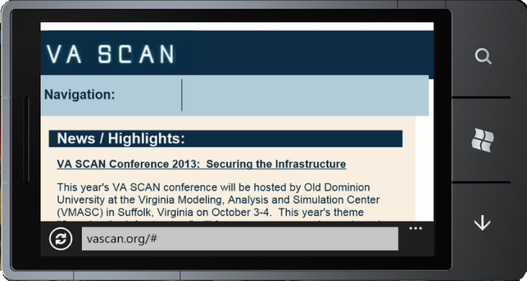

- JMU – Forbes Center (Developed with XHTML, CSS3, jQuery, YUI grids, Snapfish horizontal navigation, Nivo-Slider, and other features): http://www.jmu.edu/forbescenter/

- tech @ Beacon Deacon – my simple online site to share tech, namely web development, with some of my own articles; organized using the DataTables plug-in for jQuery: http://tech.beacondeacon.com/

- Valley Tool and Design, Inc. (Developed with HTML5/XHTML, CSS3, jQuery, YUI grids, and is responsive on multiple devices and platforms): http://valleytool-design.com

Full version:

Responsive to tablet (nav becomes a CSS dropdown):

Responsive to phones:

Windows Phone:

- JMU Mobile Site (Developed with jQuery Mobile, HTML5, compatible on multiple devices and platforms): http://m.jmu.edu (mentioned in Madison Magazine, Winter 2013, p. 15 under Connections: http://www.mydigitalrendition.com/publication/?m=20723&l=1)

- Campus Directory (including the Perl coding and LDAP coding for the search as well as the jQuery and YUI coding involved in the interface when using the cgi scripts beneath the initial page): http://www.jmu.edu/directory/

- Benefits Representative Search (Developed using jQuery Autocomplete) http://www.jmu.edu/humanresources/hrsc/benefitsrep.shtml

- AIS Reporting Tool (Developed using jQuery and Perl): http://www.jmu.edu/ais/help/report.shtml

- Barriers Reporting Tool (Developed with Perl/cgi): http://www.jmu.edu/barriers/report.shtml

- ASP tutorial site (Developed with ASP): http://people.jmu.edu/johns2ja/MyWeb/

- My own Fundraising Thermometer (Developed purely with JavaScript): http://educ.jmu.edu/~johns2ja/fundraisingthermometer.html, which I implemented on the Commonwealth of Virginia Campaign site at http://www.jmu.edu/cvc/

- Jeopardy! Game (Developed using YUI grids and jQuery); Demonstrated at Cascade Server Users Conference (Atlanta) in September 2012 during Alvin Chao’s presentation; Featured in the YUI blog at http://www.yuiblog.com/blog/2012/09/21/yui-weekly-for-sept-21st-2012: http://educ.jmu.edu/~chaoaj/csuc12/finaljeopardy.shtml

- Demo of my fluidgrids.js script for use with YUI grids (Developed with jQuery, JavaScript and YUI Grids; Demonstrated its adaptive functionality, which could be used in Responsive Web Design at Cascade Server Users Conference in September 2012 during Alvin Chao’s presentation): http://educ.jmu.edu/~chaoaj/csuc12/cascadesupportpage.shtml

- Footers Tutorial using Fancybox (Developed with Fancybox when clicking on an image): http://www.jmu.edu/cascade/tutorials/footers.shtml

- Departmental Image Generator (Developed with JavaScript): http://www.jmu.edu/wm2/docs/DeptImageGenerator/

- Color Comparison Utility (Developed with JavaScript and allows objects to be dragged for easier use): http://educ.jmu.edu/~johns2ja/colorcompare.html

- Star Wars-themed learn multiplication game for children (Developed with JavaScript and tracks where you are in the game): http://howzyerteeth.beacondeacon.com/DarthMult/

- YUI Carousel Demo Site (Developed with YUI Grids and YUI Script): http://www.jmu.edu/wm2/docs/carousel/index.shtml

- Memorial Site (Developed with YUI Grids and YUI Script): http://beacondeacon.com/pop/

- The Beacon Deacon Web Site (a current side project, which is in the process of undergoing changes to implement HTML5/CSS3 and RWD – Responsive Web Design. Some of it is already responsive): http://www.beacondeacon.com/

Full site:

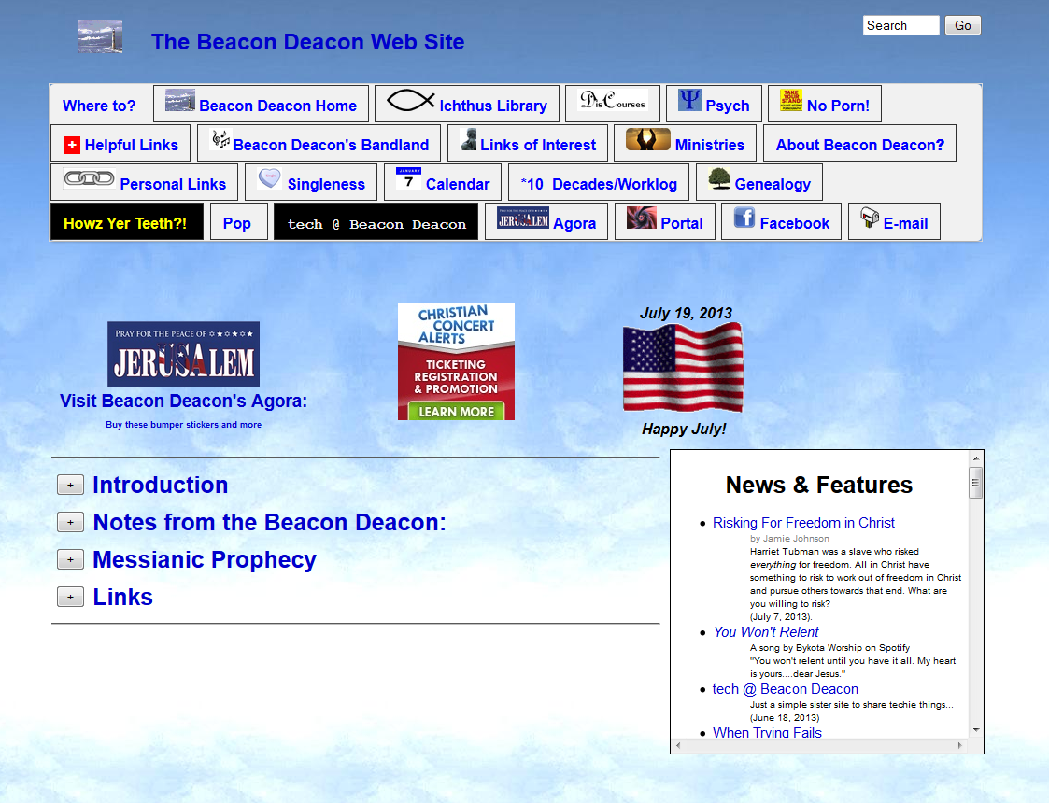

Windows Phone (responsive – including nav collapsing to a touch-activated hover menu):

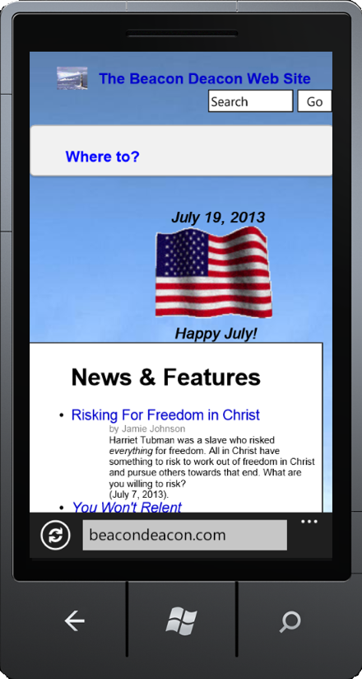
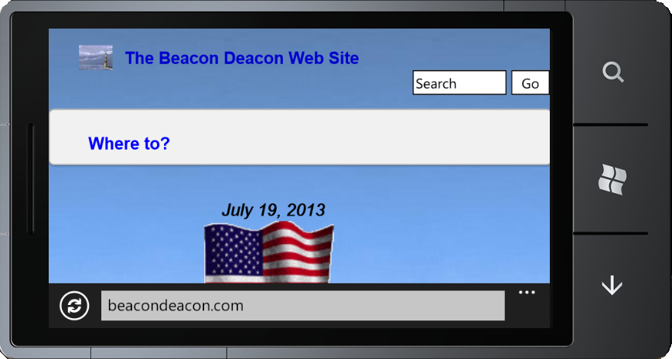

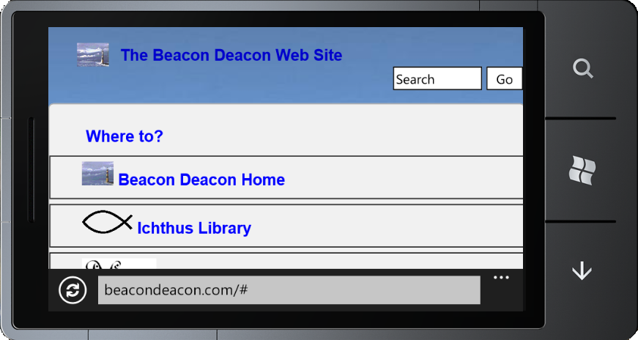

- Batman Image Carousel (Developed with PHP, YUI Grids and YUI Script and now also is adaptive): http://howzyerteeth.beacondeacon.com/Batman/images.php

- Football game (Developed with jQuery): http://howzyerteeth.beacondeacon.com/football/

- UNO! Game (Developed with JavaScript and I used CSS for the cards, no images. Also it is a single-file fully portable): http://howzyerteeth.beacondeacon.com/uno.html

- B&N Vinyl Siding and Windows, Inc. (small business site developed with YUI Grids) http://www.bnvinyl.com/

- Genealogy Site (Revamped from a rendering of the tree using ASCII characters in pretext into a site redeveloped with CSS and JavaScript): http://family.beacondeacon.com/index.htm

Protected, still in development, or retired:
- Campus Directory Administrative Application (https://www.jmu.edu/cgi-bin/directory/admin/select_d.cgi) to edit the directory (Developed in Perl/CGI using SQL code to update the databases, jQuery and JavaScript):

- Transfer Advising Snapshot Application (https://www.jmu.edu/cgi-bin/wm2/transfer/snapshots/select_ss.cgi) to edit Major and course details (Developed in Perl/CGI using SQL code to update the databases, JavaScript):
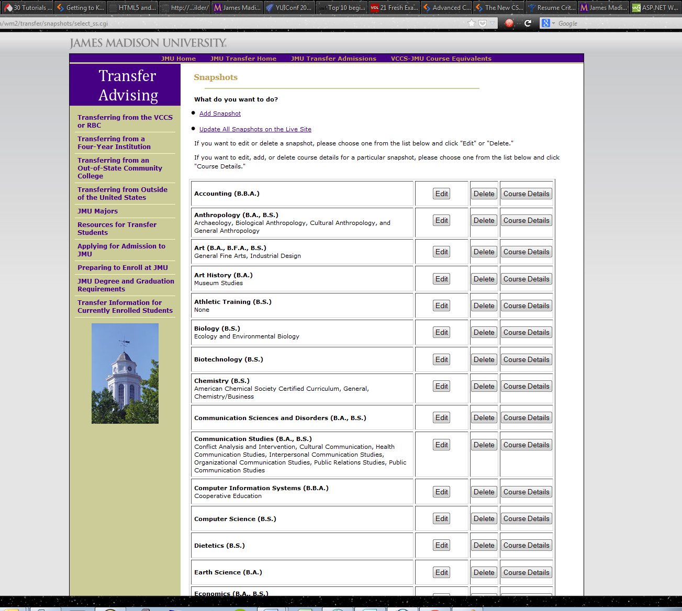

- htaccess configuration utility to set up server-side redirects or authentication on Apache servers using the tool I wrote in Cascade using both Data Definitions and a Format using XSLT:
XML produced from this particular Data Definition:
<system-data-structure>
<functionality>
<fctn>
Authentication
</fctn>
</functionality>
<authentication>
<eID>
chaoaj
</eID>
<eID>
johns2ja
</eID>
<eID>
ernstpf
</eID>
</authentication>
<redir>
<fromto>
<from>
/jamie
</from>
<to>
/computing
</to>
</fromto>
</redir>
</system-data-structure>
XSLT Format:
<xsl:stylesheet version="1.0" xmlns:xsl="http://www.w3.org/1999/XSL/Transform">
<xsl:output indent="yes" method="xml" omit-xml-declaration="yes"/>
<xsl:template match="system-data-structure">
<xsl:comment>
#START-ROOT-CODE
<xsl:variable name="function">
<xsl:value-of select="functionality/fctn"/>
</xsl:variable>
<xsl:if test="$function='Authentication'">
SSLRequireSSL
# JAMIE REMOVED A LINE IN PORTFOLIO FOR SECURITY PURPOSES; IT FORCED SSL/HTTPS
AuthType Basic
AuthName "JMU e-ID Authorization"
AuthLDAPURL # JAMIE REMOVED LDAP SERVER SPECIFICS IN PORTFOLIO FOR SECURITY PURPOSES
AuthLDAPGroupAttributeISDN On
<xsl:variable name="eID">
<xsl:value-of select="authentication/eID"/>
</xsl:variable>
<xsl:for-each select="authentication/eID">
<xsl:choose>
<xsl:when test=".=''">
require valid-user
</xsl:when>
<!-- end when-->
<xsl:otherwise>
<!-- Start otherwise, XSL version of else-->
require user
<xsl:value-of select="."/>
</xsl:otherwise>
<!-- end otherwise-->
</xsl:choose>
<!-- end choose-->
</xsl:for-each>
</xsl:if>
<xsl:if test="$function='Redirect'">
<xsl:for-each select="redir/fromto">
RedirectMatch
<xsl:value-of select="concat(from,' ',to)"/>
</xsl:for-each>
</xsl:if>
#bogus:#END-ROOT-CODE
</xsl:comment>
</xsl:template>
</xsl:stylesheet>

- Responsive Web Design development prototype – July 17, 2013
(http://www.jmu.edu/demotemplates/RWD):

Full Screen Top Section (>= 960px):

Full screen Lower Section (>=960px):

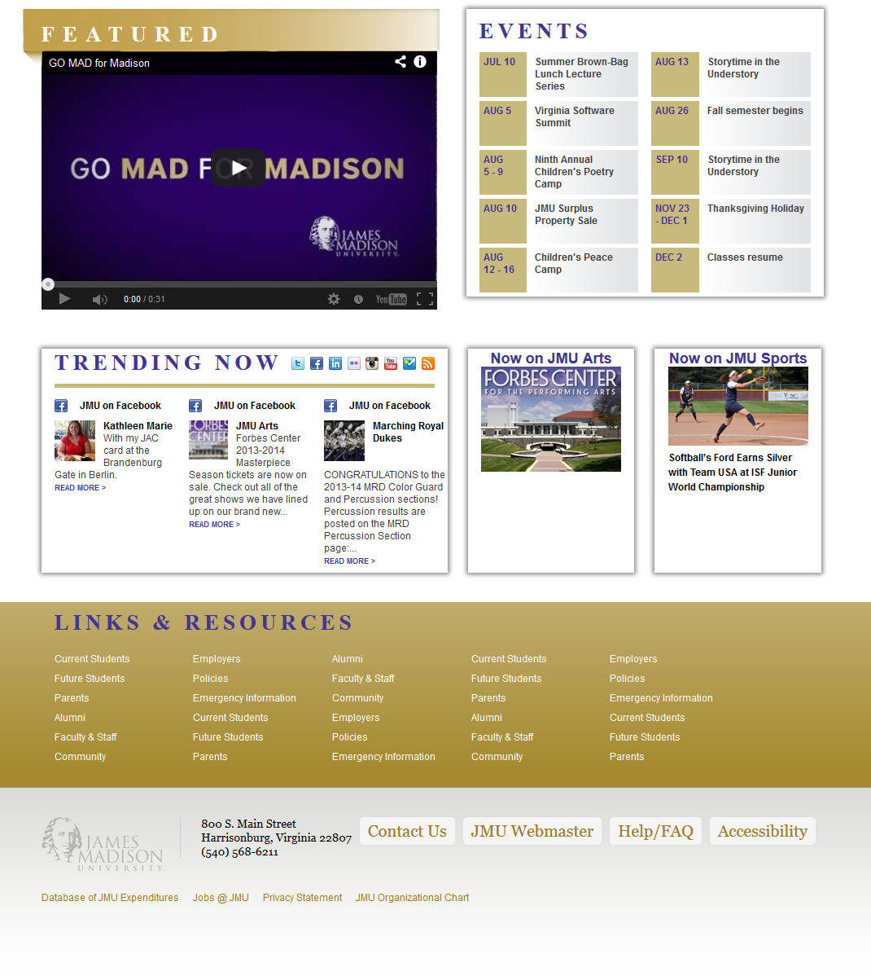

Top Section (768px breakpoint):

Mid-Section (768px breakpoint):

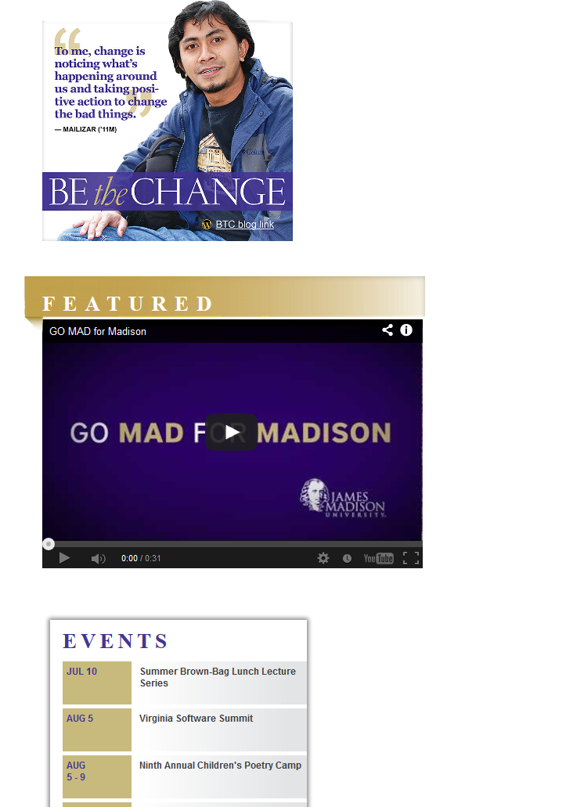

Lower Section (768px breakpoint):

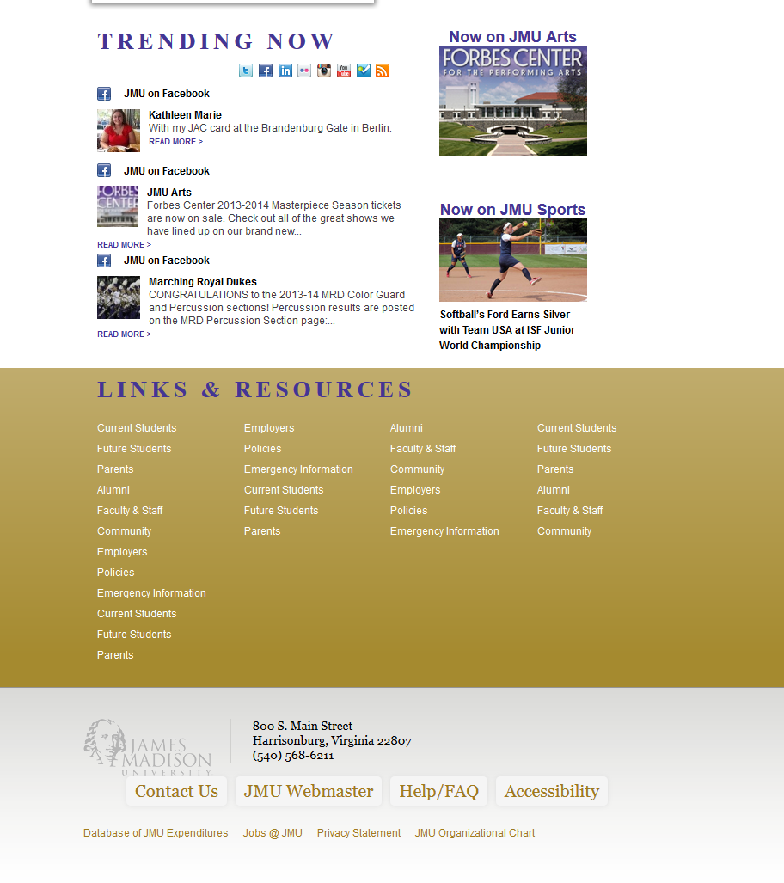

Top Section (480px breakpoint):

Top Section navigation collapses and becomes touch-activated (480px breakpoint):

Upper Mid-Section and Lower Mid-Section (480px breakpoint):

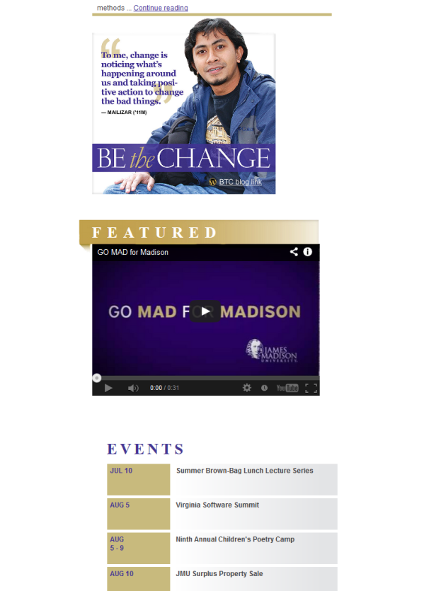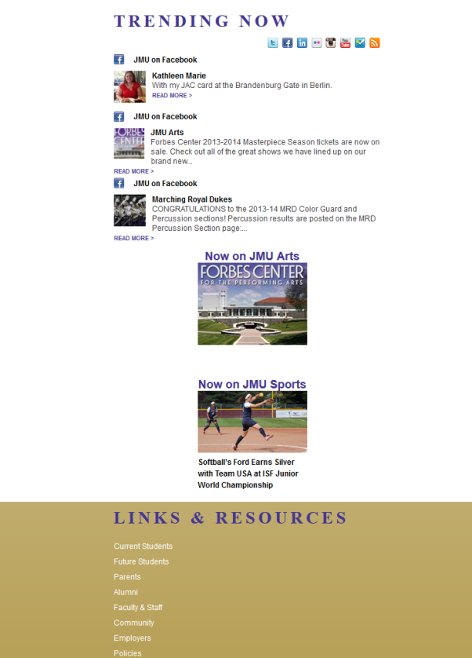

Lower Section (480px breakpoint):

Top Section and Upper Mid-Section (320px breakpoint):

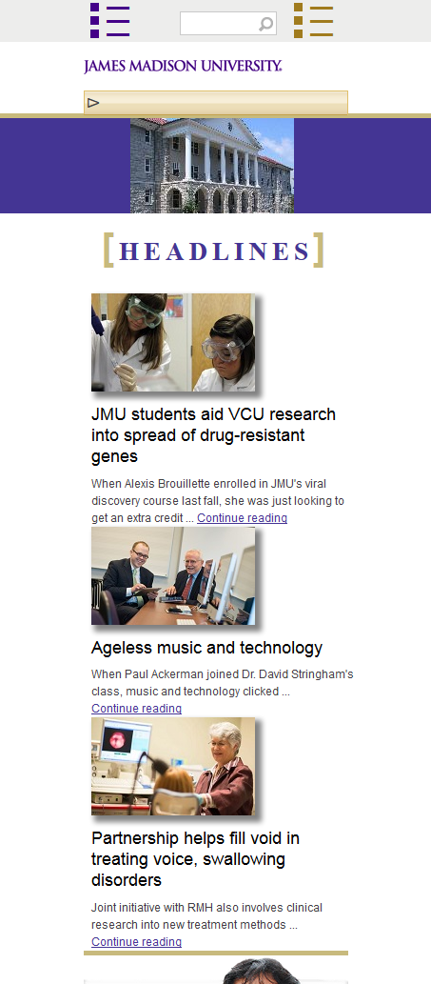

Lower Mid-Section and Lower Section (320px breakpoint):

Top Section and Upper Mid-Section (240px breakpoint):

Lower Mid-Section and Lower Section (240px breakpoint):

- Responsive Web Design development prototype – January 29, 2013
(https://www.jmu.edu/demotemplates/jamie/responsive/MANUALEDIT_events-2013-01-29-bully-documentary-film-showing.shtml):
Full screen: 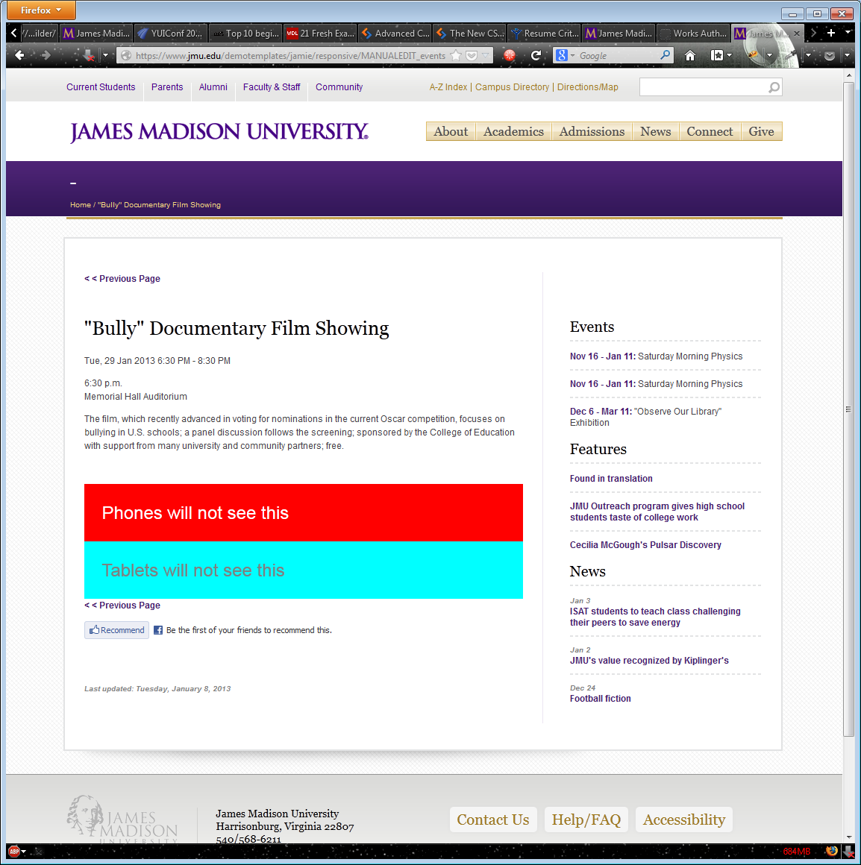

To Tablet view: 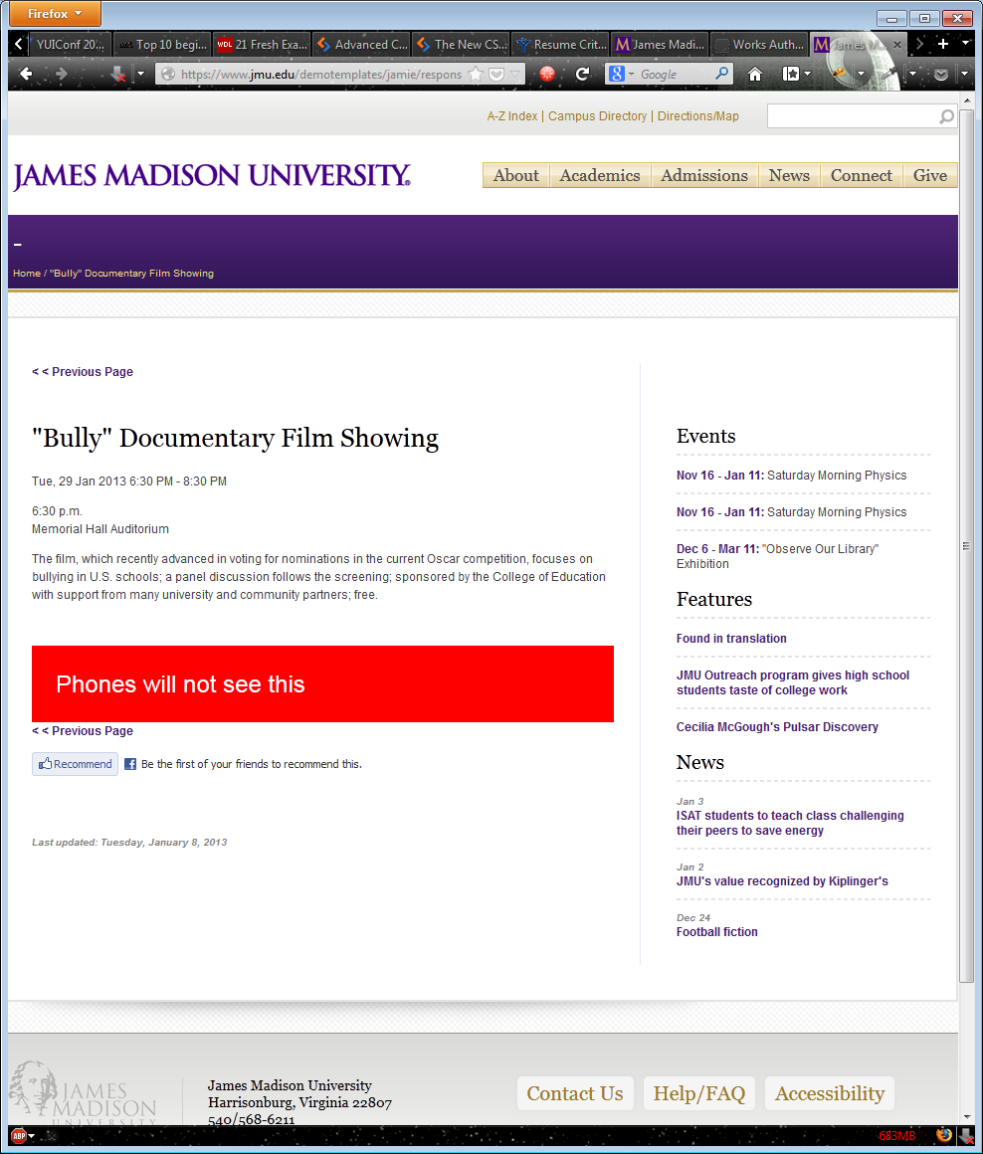

To breakpoint less than or equal to 880px:
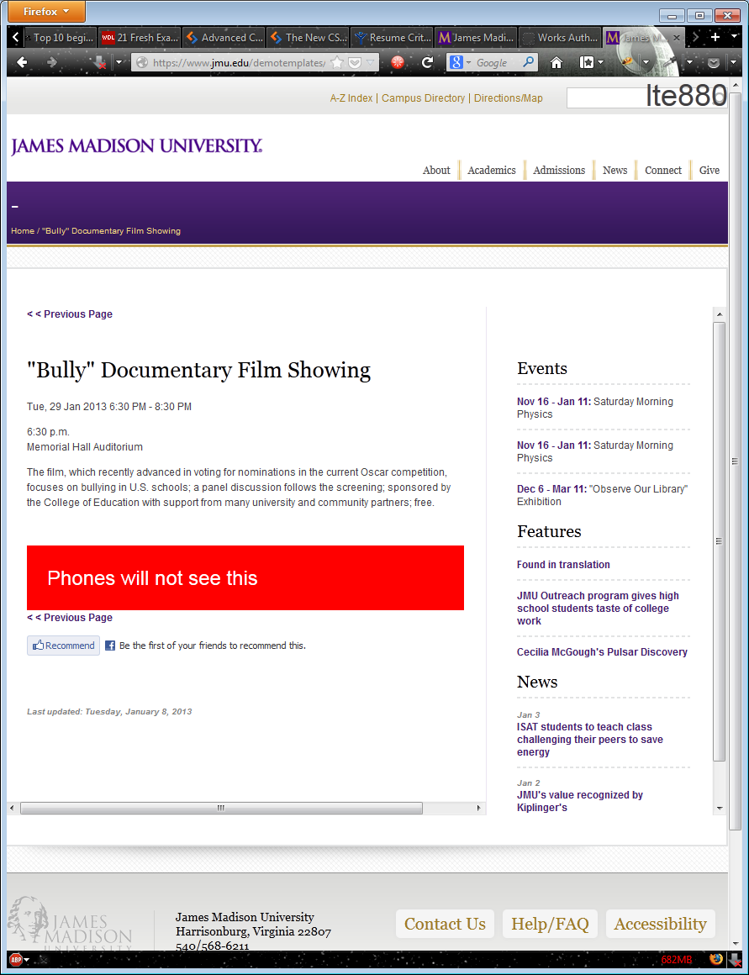
To breakpoint less than or equal to 767px (top): 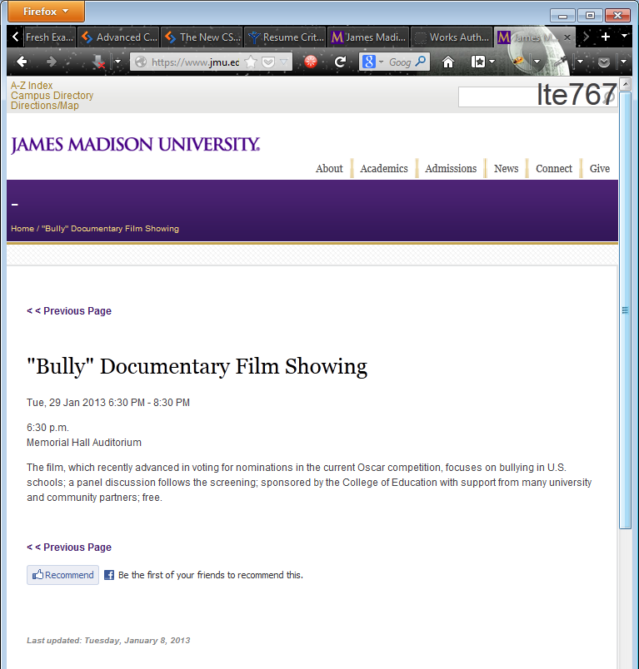

To breakpoint less than or equal to 767px (bottom scrolling down):
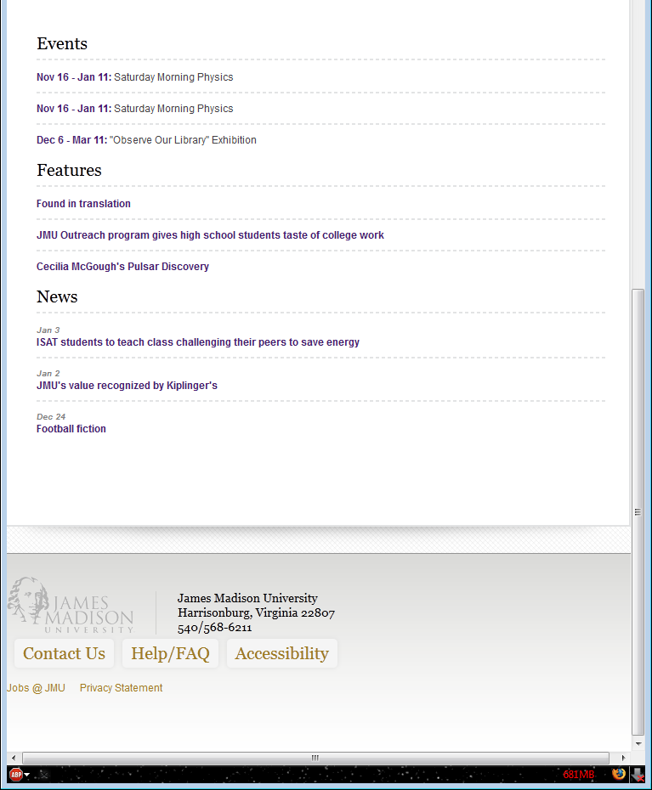

To breakpoint less than or equal to 480px (top):
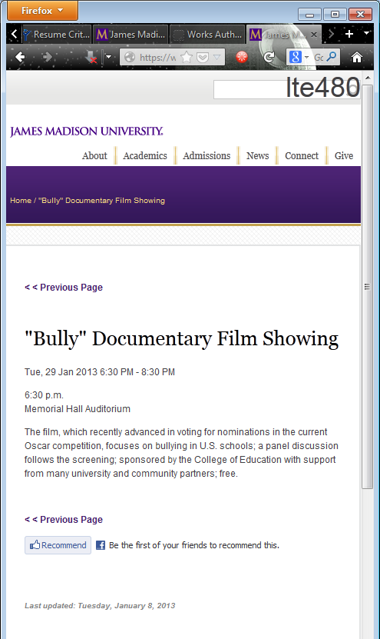

To breakpoint less than or equal to 480px (bottom): 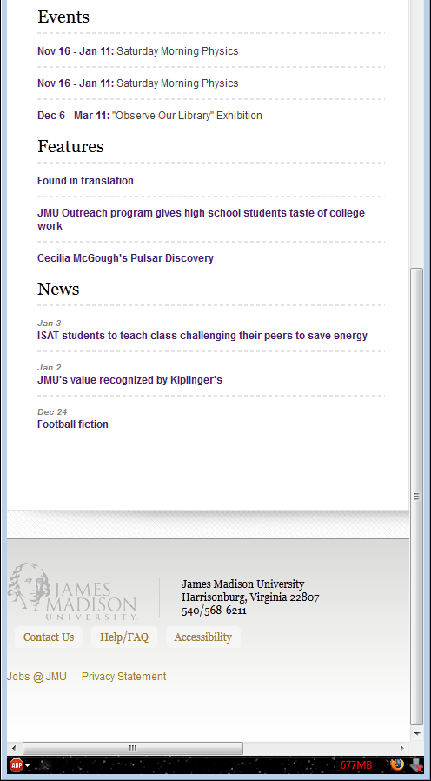

To mobile size (top):
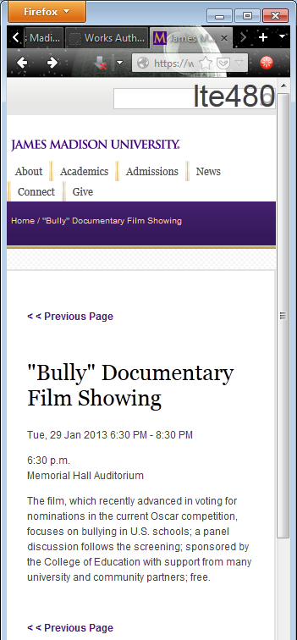

mobile size (bottom):
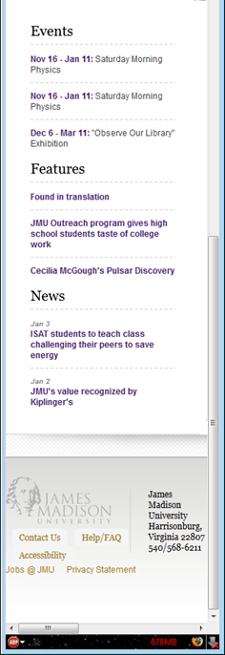

- Dynamic mini-calendar prototype in Cascade (using jQuery and VelocityScript, the latter being a cousin to Java and used for parsing XML similar to how XSLT does, but with methods and object-oriented programming features. When there is an event, it highlights the day and becomes linkable to the event for the web site. There are still discussions about where to use it):
- Advantage Physical Therapy and Sports Performance (company merged with another company and site has been revamped by a new webmaster; original site I developed in PHP):

- Help Desk Quick Links “App” for frontline staff (I wrote this prior to 2008 when I worked at the Help Desk; Developed using JavaScript):
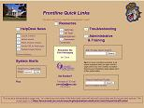

- Mac OS X Leopard Desktop Emulation page for documentation and training/tutorial (Developed with JavaScript):
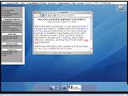

- Byler Barns (site has new webmaster):

- Gandhi Center (site has been taken over since I worked on it in 2009 and looks different):
