Schedule of Events
Team Registration 8:00 – 9:00
Opening Ceremony 9:00 – 9:15
Competition Events 9:20 – 2:45
Robot Performance
Robot Design
Project Presentation
Teamwork
Parade of Teams 3:00 – 3:10
Closing Ceremony 3:10 – 3:30

Event Locations
Pit Area – Spectators Welcomed
Division 2 - Gymnasium

Robot Performance – Spectators Welcomed
All Teams - Main Gymnasium

Robot Design – Teams Only
Robot Design 1 – Room 105
Robot Design 2 – Room 108

Project Presentation – Teams Only
Project Presentation 1 – Room 101
Project Presentation 2 – Room 103

Core Values – Teams Only
Core Values 1 – Room 107
Core Values 2– Room 112

Behavior and Safety Guidelines
Judging sessions are only open to the team as well as up to two coaches/mentors and one historian (adult videotaping or taking picture). No other spectators are allowed.

Please remember that everyone is expected to display gracious professionalism (teams, coaches, parents, volunteers)

Please walk through the hallways and be aware of others around you. There will be a lot of kids and spectators.

Safety Exits – are clearly marked throughout the school.

Challenge Background
Senior Solutions
Independent. Engaged. Connected.

Can FIRST® LEGO® League teams improve the quality of life for seniors by helping them continue to be independent, engaged, and connected in their communities?

Scoring Processes
Robot Design 33.3%
Project Presentation 33.3%
Core Values 33.3%

Insert School Map Here

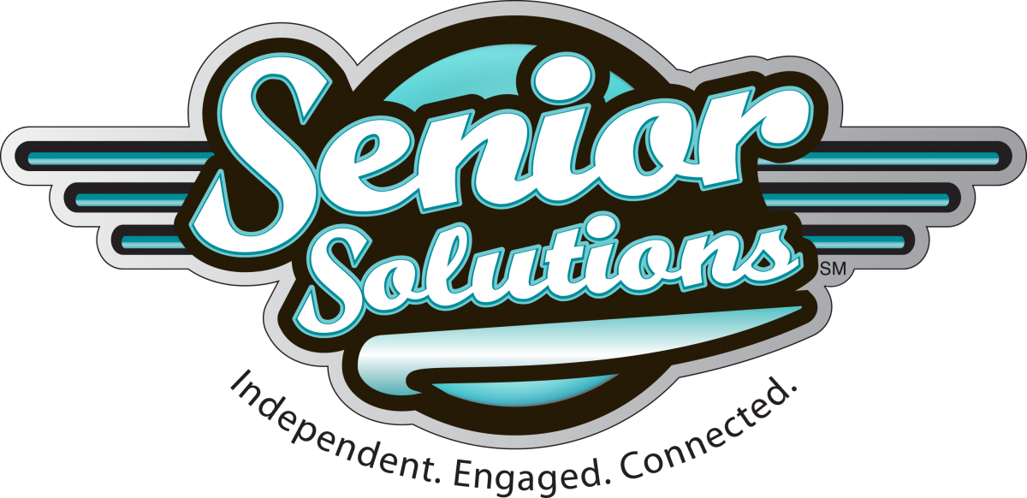

2012 Championship Tournament
December 8th -9th
James Madison University, Harrisonburg, VA

About FIRST
FIRST (For Inspiration and Recognition of Science and Technology) was founded in 1989 by inventor Dean Kamen to inspire young people’s interest and participation in science and technology. Based in Manchester, NH, FIRST is a 501 (c) (3) not-for-profit public charity. FIRST is supported by a strong network of sponsors and volunteers.

FIRST provides the FIRST Robotics Competition for high-school students and the FIRST LEGO League for 9 to 14 year-olds. FIRST also offers the Junior FIRST LEGO League for 6 to 9 year-olds and the FIRST Tech Challenge, a mid-level robotics competition that offers high-school students a more affordable and accessible opportunity to participate in FIRST. For more information, visit usfirst.org.

About the LEGO Group
The LEGO Group, a privately-held, family-owned company based in Billund, Denmark, is one of the world's leading manufacturers of high quality, creatively educational play materials for children. The company is committed to the development of children's creative and imaginative abilities, and its employees are guided by the motto adopted in the 1930s by founder Ole Kirk Christiansen: "Only the best is good enough." For more information, visit www.LEGO.com.

LEGO, MINDSTORMS and their respective logos are trademarks of The LEGO Group.
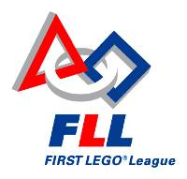

Welcome to the
Virginia / DC
FIRST® LEGO® League

Crittenden Middle School

Regional Qualifying Tournament

Saturday November 5th, 2011

Sponsored by:



Newport News Public Schools
AIAA (Hampton Roads Section)
BAE Systems

