Bloom's Taxonomy Blooms Digitally
By Andrew Churches, April 1, 2008
from Educators' eZine
Introduction and Background:
Bloom's Taxonomy
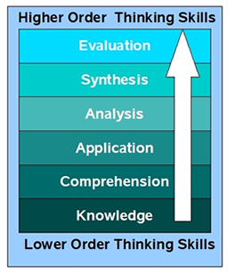
In the 1950's Benjamin Bloom developed his taxonomy of cognitive objectives, Bloom's Taxonomy. This categorized and ordered thinking skills and objectives. His taxonomy follows the thinking process. You can not understand a concept if you do not first remember it, similarly you can not apply knowledge and concepts if you do not understand them. It is a continuum from Lower Order Thinking Skills (LOTS) to Higher Order Thinking Skills (HOTS). Bloom labels each category with a gerund.
Bloom's Revised Taxonomy
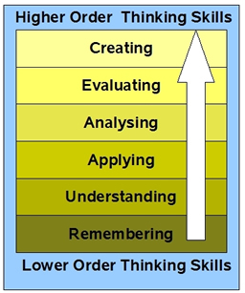
In the 1990's, a former student of Bloom, Lorin Anderson, revised Bloom's Taxonomy and published this- Bloom's Revised Taxonomy in 2001.Key to this is the use of verbs rather than nouns for each of the categories and a rearrangement of the sequence within the taxonomy. They are arranged below in increasing order, from low to high.
Bloom's Revised Taxonomy Sub Categories
Each of the categories or taxonomic elements has a number of key verbs associated with it
Lower Order Thinking Skills (LOTS)
- Remembering - Recognising, listing, describing, identifying, retrieving, naming, locating, finding
- Understanding - Interpreting, Summarising, inferring, paraphrasing, classifying, comparing, explaining, exemplifying
- Applying - Implementing, carrying out, using, executing
- Analysing - Comparing, organising, deconstructing, Attributing, outlining, finding, structuring, integrating
- Evaluating - Checking, hypothesising, critiquing, Experimenting, judging, testing, Detecting, Monitoring
- Creating - designing, constructing, planning, producing, inventing, devising, making
Higher Order Thinking Skills (HOTS)
The elements cover many of the activities and objectives but they do not address the new objectives presented by the emergence and integration of Information and Communication Technologies into the classroom and the lives of our students.
Bloom's digital taxonomy map
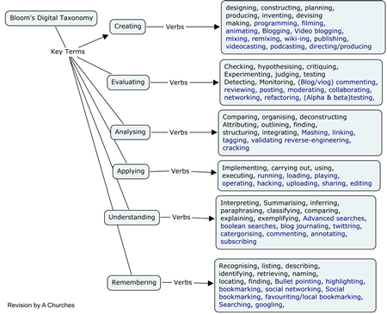
Key:
Elements coloured in black are recognised and existing verbs, Elements coloured in blue are new digital verbs.
Remembering
This element of the taxonomy does infer the retrieval of material. This is a key element given the growth in knowledge and information.
The digital additions and their explanations are as follows:
- Bullet pointing – This is analogous to listing but in a digital format.
- Highlighting – This is a key element of most productivity suites; encouraging students to pick out and highlight key words and phrases is a technique for recall.
- Bookmarking or favorite-ing – this is where the students mark for later use web sites, resources and files. Students can then organise these.
- Social networking – this is where people develop networks of friends and associates. It forges and creates links between different people. Like social bookmarks (see below) a social network can form a key element of collaborating and networking.
- Social bookmarking – this is an online version of local bookmarking or favorites, It is more advanced because you can draw on others' bookmarks and tags. While higher order thinking skills like collaborating and sharing, can and do make use of these skills, this is its simplest form - a simple list of sites saved to an online format rather than locally to the machine.
- Searching or "Googling" - Search engines are now key elements of students' research. At its simplest the student is just entering a key word or phrase into the basic entry pane of the search engine. This skill does not refine the search beyond the key word or term.
Key Terms - Remembering:
Recognizing, listing, describing, identifying, retrieving, naming, locating, finding, Bullet pointing, highlighting, bookmarking, social networking, Social bookmarking, favorite-ing/local bookmarking, Searching, Googling.
Understanding
The digital additions and their explanations are as follows:
- Advanced and Boolean Searching – This is a progression from the previous category. Students require a greater depth of understanding to be able to create, modify and refine searches to suit their search needs.
- Blog Journaling – This is the simplest of the uses for a blog, where a student simply "talks" "writes" or "types" a daily- or task-specific journal. This shows a basic understanding of the activity reported upon. The blog can be used to develop higher level thinking when used for discussion and collaboration.
- Twittering – The Twitter site's fundamental question is "what are you doing?" This can be, in its most simplistic form, a one or two word answer, but when developed this is a tool that lends itself to developing understanding and potentially starting collaboration.
- Categorizing – digital classification - organizing and classifying files, web sites and materials using folders etc.
- Commenting and annotating – a variety of tools exist that allow the user to comment and annotate on web pages, .pdf files and other documents. The user is developing understanding by simply commenting on the pages. This is analogous with writing notes on hand outs, but is potentially more powerful as you can link and index these.
- Subscribing – Subscription takes bookmarking in its various forms and simplistic reading one level further. The act of subscription by itself does not show or develop understanding but often the process of reading and revisiting the subscribed-to feeds leads to greater understanding.
Key Terms - Understanding:
Interpreting, Summarizing, inferring, paraphrasing, classifying, comparing, explaining, exemplifying, Advanced searching, Boolean searching, blog journaling, twittering, categorising and tagging, commenting, annotating, subscribing.

Applying
The digital additions and their justifications are as follows:
- Running and operating – This is the action of initiating a program or operating and manipulating hardware and applications to obtain a basic goal or objective.
- Playing – The increasing emergence of games as a mode of education leads to the inclusion of this term in the list. Students who successfully play or operate a game are showing understanding of process and task and application of skills.
- Uploading and Sharing - uploading materials to websites and the sharing of materials via sites like flickr etc. This is a simple form of collaboration, a higher order thinking skill.
- Hacking – hacking in its simpler forms is applying a simple set of rules to achieve a goal or objective.
- Editing – With most media, editing is a process or a procedure that the editor employs.
Key Terms - Applying:
Implementing, carrying out, using, executing, running, loading, playing, operating, hacking, uploading, sharing, editing.
Analysing
The digital additions and their explanations are as follows:
- Mashing – mash ups are the integration of several data sources into a single resource. Mashing data currently is a complex process but as more options and sites evolve this will become an increasingly easy and accessible means of analysis.
- Linking – this is establishing and building links within and outside of documents and web pages.
- Reverse-engineering – this is analogous with deconstruction. It is also related to cracking often with out the negative implications associated with this.
- Cracking – cracking requires the cracker to understand and operate the application or system being cracked, analyse its strengths and weaknesses and then exploit these.
- Validating – With the wealth of information available to students combined with the lack of authentication of data, students of today and tomorrow must be able to validate the veracity of their information sources. To do this they must be able to analyse the data sources and make judgements based on these.
- Tagging – This is organising, structuring and attributing online data, meta-tagging web pages etc. Students need to be able understand and analyse the content of the pages to be able to tag it.
Key Terms - Analysing:
Comparing, organising, deconstructing, Attributing, outlining, finding, structuring, integrating, Mashing, linking, reverse-engineering, cracking, mind-mapping, validating, tagging.
Evaluating
The digital additions and their explanations are as follows:
- Blog/vlog commenting and reflecting – Constructive criticism and reflective practice are often facilitated by the use of blogs and video blogs. Students commenting and replying to postings have to evaluate the material in context and reply.
- Posting – posting comments to blogs, discussion boards, threaded discussions. These are increasingly common elements of students' daily practice. Good postings like good comments, are not simple one-line answers but rather are structured and constructed to evaluate the topic or concept.
- Moderating – This is high level evaluation; the moderator must be able to evaluate a posting or comment from a variety of perspectives, assessing its worth, value and appropriateness.
- Collaborating and networking – Collaboration is an increasing feature of education. In a world increasingly focused on communication, collaboration leading to collective intelligence is a key aspect. Effective collaboration involves evaluating the strengths and abilities of the participants and evaluating the contribution they make. Networking is a feature of collaboration, contacting and communicating with relevant person via a network of associates.
- Testing (Alpha and Beta) – Testing of applications, processes and procedures is a key element in the development of any tool. To be an effective tester you must have the ability to analyze the purpose of the tool or process, what its correct function should be and what its current function is.
Key Terms – Evaluating:
Checking, hypothesising, critiquing, experimenting, judging, testing, detecting, monitoring, (Blog/vlog) commenting, reviewing, posting, moderating, collaborating, networking, reflecting, (Alpha & beta) testing.
Creating
The digital additions and their explanations are as follows:
- Programming – Whether it is creating their own applications, programming macros or developing games or multimedia applications within structured environments, students are routinely creating their own programs to suit their needs and goals.
- Filming, animating, videocasting, podcasting, mixing and remixing – these relate to the increasing availability of multimedia and multimedia editing tools. Students frequently capture, create, mix and remix content to produce unique products.
- Directing and producing – to directing or producing a product, performance or production is a highly creative process. It requires the student to have vision, understand the components and meld these into a coherent product.
- Publishing – whether via the web or from home computers, publishing in text, media or digital formats is increasing. Again this requires a huge overview of not only the content being published, but the process and product. Related to this concept are also Video blogging – the production of video blogs, blogging and also wiki-ing - creating, adding to and modify content in wikis. Creating or building Mash ups would also fit here.
Key Terms – Creating:
designing, constructing, planning, producing, inventing, devising, making, programming, filming, animating, Blogging, Video blogging, mixing, remixing, wiki-ing, publishing, videocasting, podcasting, directing/producing, creating or building mash ups.
Bibliography
Churches, A. 2007, Educational Origami, Bloom's and ICT Tools
Anderson, L.W., and D. Krathwohl (Eds.) (2001). A Taxonomy for Learning, Teaching and Assessing: a Revision of Bloom's Taxonomy of Educational Objectives. Longman, New York.
Acknowledgements: For assistance, discussion and often punctuation:Miguel Guhlin, Sheryl Nussbaum-Beach, Alan Knightbridge, Sue Cattell, Raewyn Casey, Marg McLeod, Doug DeKock

.

